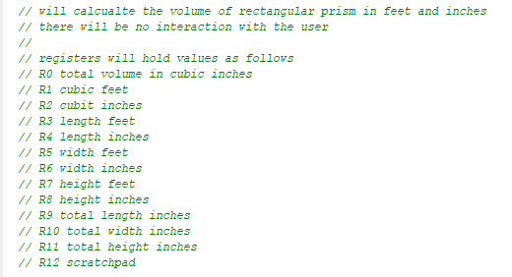



L = 2’0’’ = 24’’ = 0018h

W = 1’ 2’’ = 14’’ = 000eh

H = 0’ 6’’ = 6’’ = 0006h

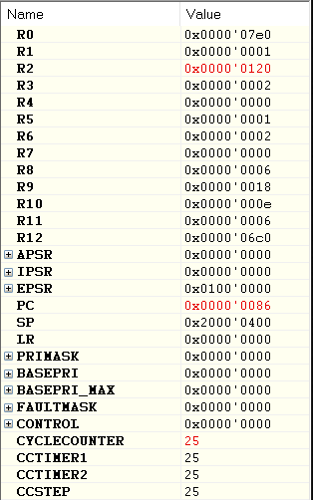

Total Height (Inches)

Total Width (Inches)

Total Length (Inches)

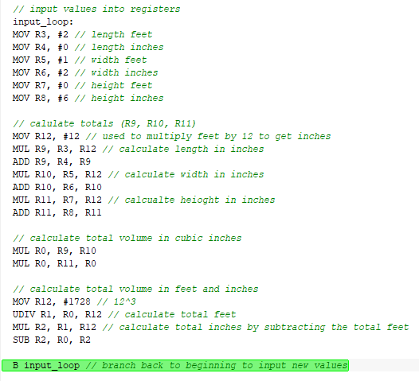

L = 3’4’’ =40’’ = 0028h

W = 0’ 2’’ = 2’’ = 0002h

H = 5’ 6’’ = 66’’ = 004eh

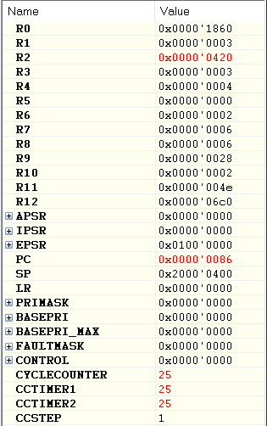

Total Height (Inches)

Total Width (Inches)

Total Length (Inches)

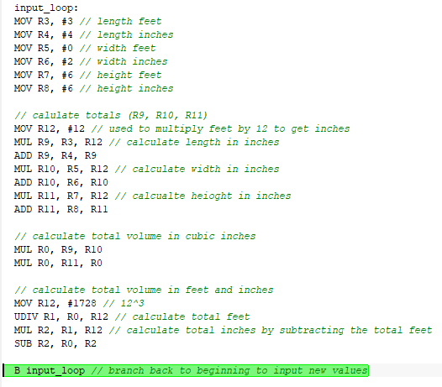

L = 5’11’’ =71’’ = 0047h

W = 3’ 0’’ = 36’’ = 0024h

H = 7’ 6’’ = 90’’ = 005ah

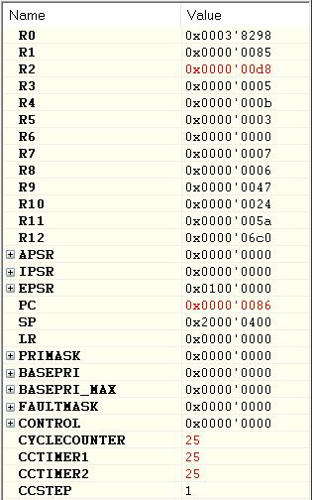

Total Height (Inches)

Total Width (Inches)

Total Length (Inches)

